Q5.

State representation:

* Each piece can be assigned a unique number from 1 to n to represent it. Each jigsaw rectangle grid can be represented as a (m x k) matrix. The position in the matrix corresponds to the position in the puzzle set. The number in that position corresponds to the respective puzzle piece. A zero can be used to represent an empty space.
* Overall, the matrix represents a valid configuration of puzzle pieces

Initial state:

* An (m x k) matrix filled with zeros
* This represents an empty grid

Actions:

* The action is to place a puzzle piece into an empty grid as long as it can fit with the existing pieces
* Place(piece, position)

Transition Model:

* g: Matrix x Place(piece, position)
* e.g. for a 2 by 3 puzzle, assuming all the pieces fit correctly and that 3 is a corner piece,

$$\left[\begin{matrix}3 & 6 & 0 \\ 0 & 0 & 0\end{matrix}\right]-place\left(1, \left(2,1\right)\right)→\left[\begin{matrix}3 & 6 & 0 \\ 1 & 0 & 0\end{matrix}\right]$$

Step Cost:

* Time taken to find the piece from the current available pieces and to place it in the given position

Goal Test:

* The matrix has no zeros and the configuration of puzzle pieces are valid (i.e. all the pieces fit together, the corners only have corner pieces and the edges only have edge pieces)

Q6.

(a)

Assuming nodes are explored when they are checked for the goal, the explored subgraph is:

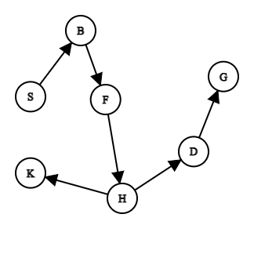

(b)

Path: S – B – F – H – D – G